SYSTEM ARCHITECTURE
  - DATA FLOW DIAGRAMS

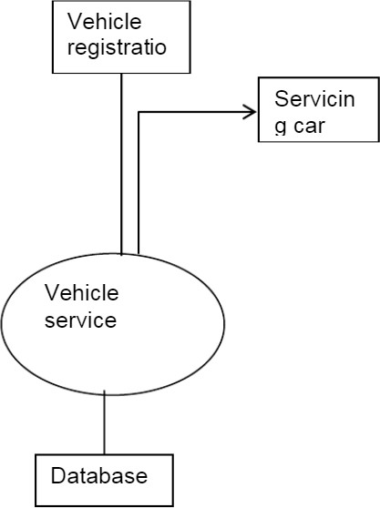

UML DIAGRAMS

UML stands for Unified Modeling Language. UML is a standardized general-purpose modeling language in the field of object-oriented software engineering. The standard is managed, and was created by, the Object Management Group.
The goal is for UML to become a common language for creating models of object oriented computer software. In its current form UML is comprised of two major components: a Meta-model and a notation. In the future, some form of method or process may also be added to; or associated with, UML.
The Unified Modeling Language is a standard language for specifying, Visualization, Constructing and documenting the artifacts of software system, as well as for business modeling and other non-software systems.
The UML represents a collection of best engineering practices that have proven successful in the modeling of large and complex systems.
The UML is a very important part of developing objects oriented software and the software development process. The UML uses mostly graphical notations to express the design of software projects.

GOALS:
The Primary goals in the design of the UML are as follows:
    - Provide users a ready-to-use, expressive visual modeling Language so that they can develop and exchange meaningful models.
    - Provide extendibility and specialization mechanisms to extend the core concepts.
    - Be independent of particular programming languages and development process.
    - Provide a formal basis for understanding the modeling language.
    - Encourage the growth of OO tools market.
    - Support higher level development concepts such as collaborations, frameworks, patterns and components.
    - Integrate best practices.

USE CASE DIAGRAM:
A use case diagram in the Unified Modeling Language (UML) is a type of behavioral diagram defined by and created from a Use-case analysis. Its purpose is to present a graphical overview of the functionality provided by a system in terms of actors, their goals (represented as use cases), and any dependencies between those use cases

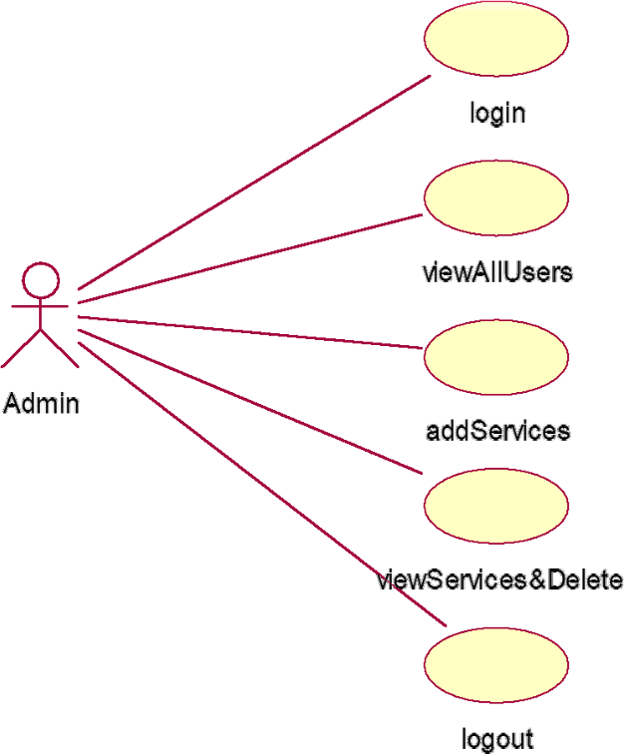

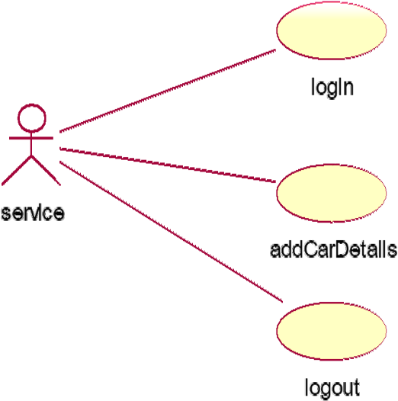

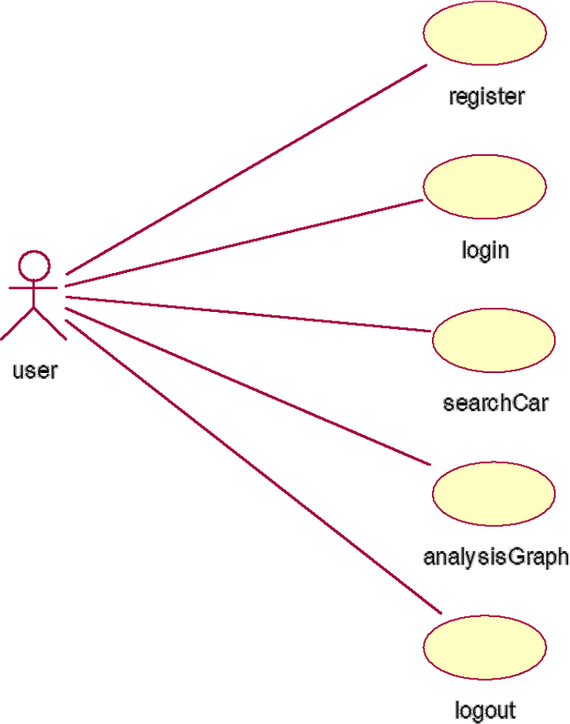

CLASS DIAGRAM:
In software engineering, a class diagram in the Unified Modeling Language (UML) is a type of static structure diagram that describes the structure of a system by showing the system's classes, their attributes, operations (or methods), and the relationships among the classes. It explains which class contains information.

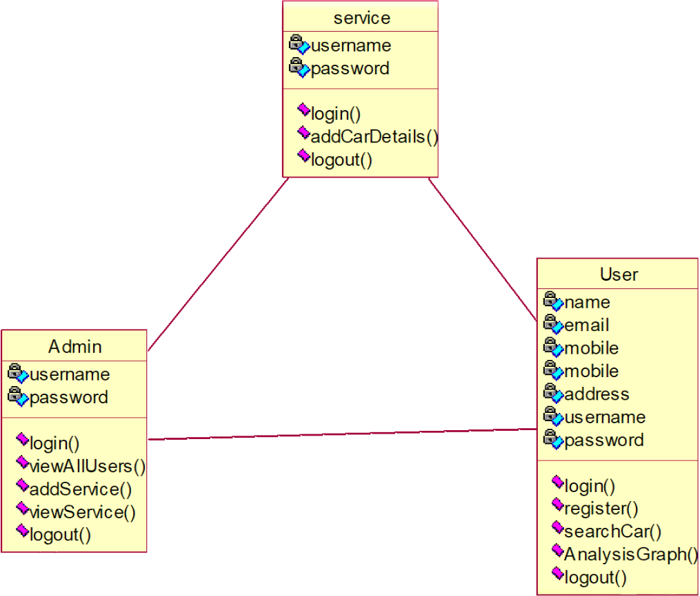

SEQUENCE DIAGRAM:
A sequence diagram in Unified Modeling Language (UML) is a kind of interaction diagram that shows how processes operate with one another and in what order. It is a construct of a Message Sequence Chart. Sequence diagrams are sometimes called event diagrams, event scenarios, and timing diagrams.

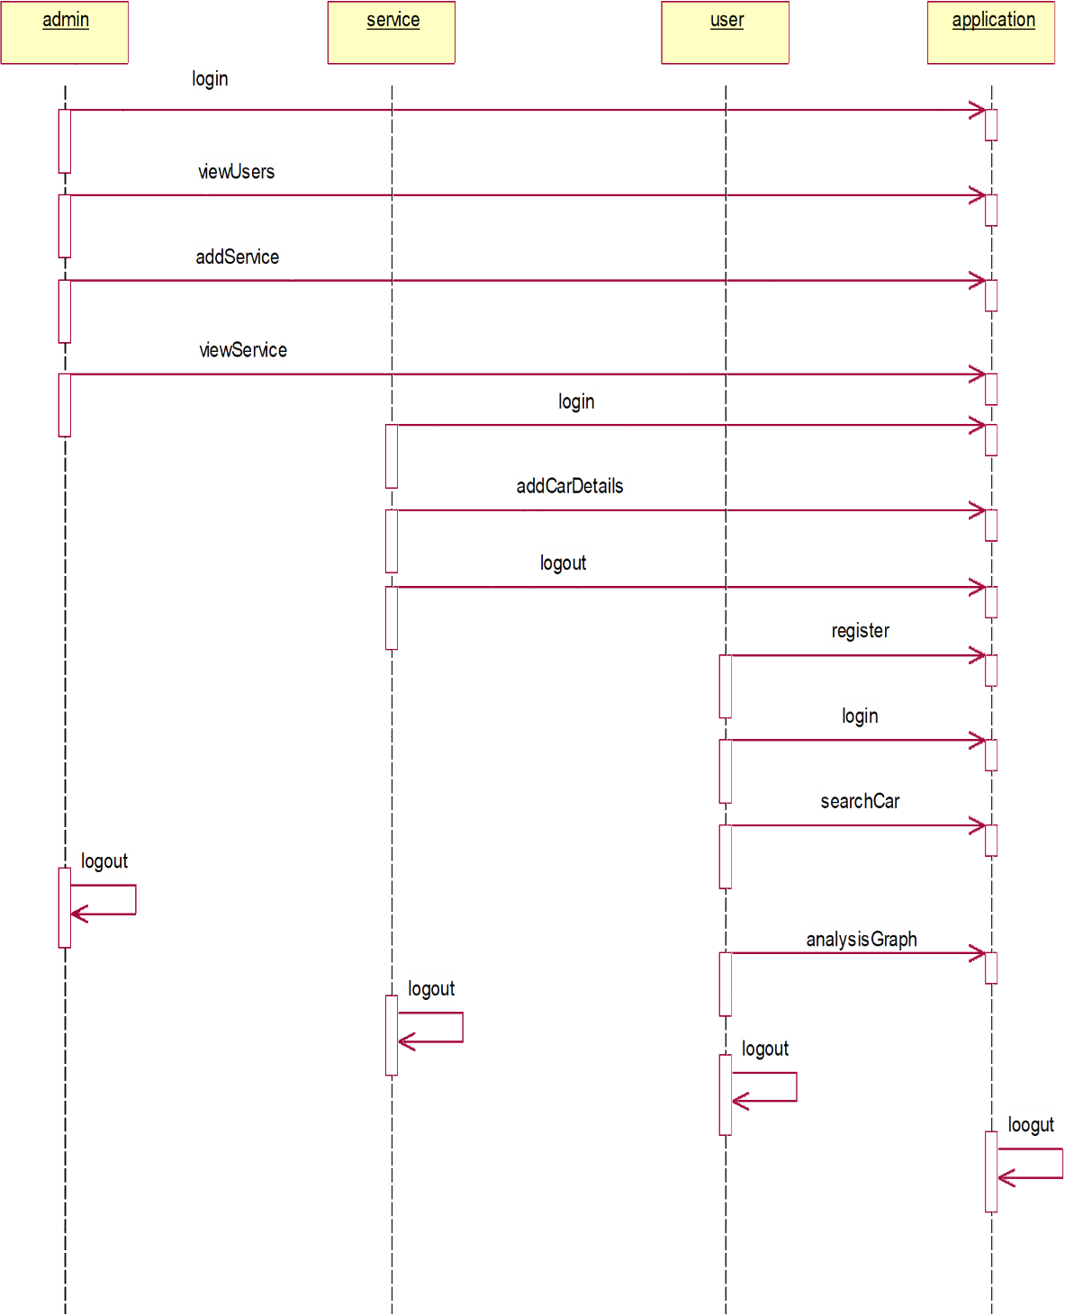
COLLABORATION
Collaboration is a working practice whereby individuals work together for a common purpose to achieve business benefit. Collaboration enables individuals to work together to achieve a defined and common business purpose.
